**PYCARET IMPLEMENTATION**

**Purpose**

Implementing/Comparing/Testing all Classification, Regression and Anomaly Detection algorithm on different datasets. Purpose of this project is to get familiar with PyCaret.

**Data Details**

1. Here we are using inhouse data which comes with PyCaret module

* **Anomaly** data for Anomaly Detection
* **Diabetes** data for Classification
* **Boston** data for Regression

1. Using the Anomaly dataset, we will be identifying rare items, events or observations which raise suspicions by differing significantly from the majority of the data. This dataset has 10 columns.
2. Using the Diabetes dataset, we will be predicting if the person has diabetes or not. This dataset has 9 columns.
3. Using the Boston dataset, we will be predicting crime rate in Boston. This dataset has 9 columns.

**Files used to run the model**

1. Anomaly Detection using PyCaret.ipynb
2. Classification using PyCaret.ipynb
3. Regression using PyCaret.ipynb

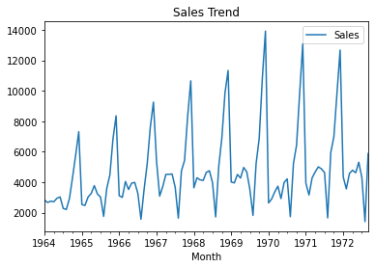

Sales Data

